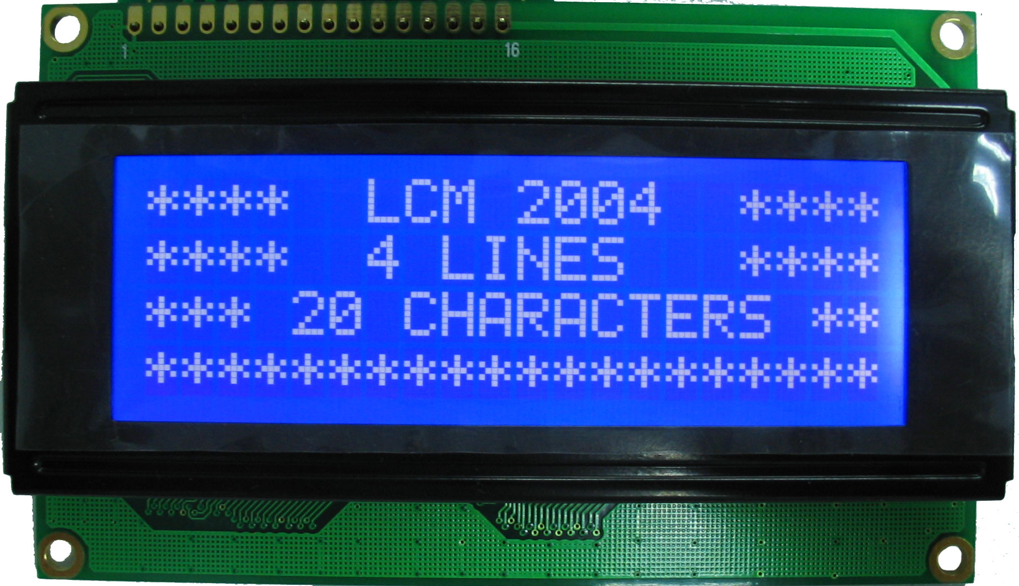
Showing Words on an LCD

- Create the circuit shown on last page
- Open the Arduino IDE program on your computer
- Copy and paste the code below into the Arduino IDE
- Upload code to arduino
- The LCD screen should now show text

Extensions

- Change code to some text you want it to show
- Add a push button and change some code to change the text when you press the code.

Program Code (Copy and Paste the following)
#include <LiquidCrystal.h>
LiquidCrystal lcd(12, 11, 10, 5, 4, 3, 2);
int backLight = 13; // pin 13 will control the backlight
void setup()
{
pinMode(backLight, OUTPUT);
digitalWrite(backLight, HIGH); // turn backlight on. Replace 'HIGH' with 'LOW' to turn it off.
lcd.begin(20,4); // columns, rows. use 16,2 for a 16x2 LCD, etc.
}
void loop()
{
lcd.clear(); // start with a blank screen
lcd.setCursor(0,0); // set cursor to column 0, row 0 (the first row)
lcd.print("Hello, World");// change this text to whatever you like. keep it clean.
lcd.setCursor(0,1); // set cursor to column 0, row 1
lcd.print("Your Text Here");
lcd.setCursor(0,2); // set cursor to column 0, row 2
lcd.print("Row 3");
lcd.setCursor(0,3); // set cursor to column 0, row 3
lcd.print("Row 4");
}
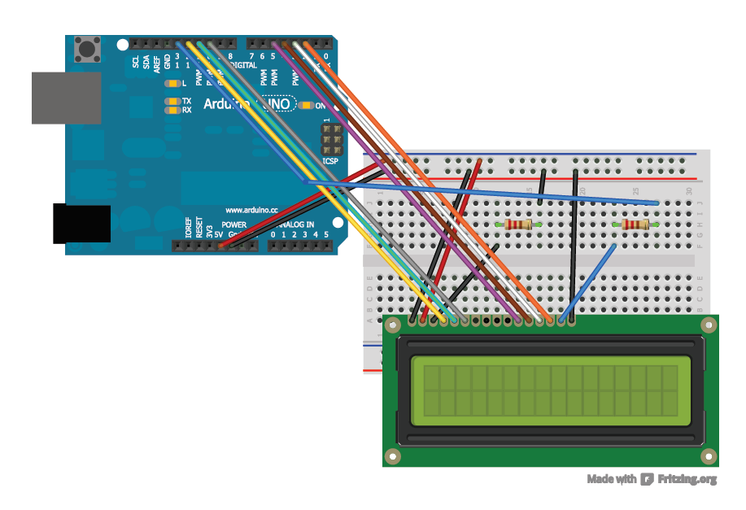
Circuit Diagram

